**Mini Project Report on**



**Online Food Ordering System**



**Submitted in partial fulfilment of the requirement for the award of the degree of**

**BACHELOR OF TECHNOLOGY**

**IN**

**COMPUTER SCIENCE & ENGINEERING**

**Submitted by:**

**Student Name TANMAY SAXENA University Roll No. 2019179**

***Under the Mentorship of***

**Mentor Name: Mr. Pramod Mehra**

**Assistant Professor**



**Department of Computer Science and Engineering**

**Graphic Era (Deemed to be University)**

**Dehradun, Uttarakhand**

**July-2023**



**CANDIDATE’S DECLARATION**

I hereby certify that the work which is being presented in the project report entitled **“Online Food Ordering System”** in partial fulfillment of the requirements for the award of the Degree of Bachelor of Technology in Computer Science and Engineeringof the Graphic Era (Deemed to be University), Dehradun shall be carried out by the under the mentorship of **Mr. Pramod Mehra, Assistant Professor**, Department of Computer Science and Engineering, Graphic Era (Deemed to be University), Dehradun.

Name TANMAY SAXENA University Roll no. 2019179

**Table of Contents**

|  |  |  |
| --- | --- | --- |
| **Chapter No.** | **Description** | **Page No.** |
| Chapter 1 | Introduction | 1-2 |
| Chapter 2 | Literature Survey | 3-4 |
| Chapter 3 | Methodology | 5-8 |
| Chapter 4 | Result and Discussion | 9-14 |
| Chapter 5 | Conclusion and Future Work | 15-16 |
|  | References | 17 |

**Chapter 1**

**Introduction**

The Online Ordering System revolutionizes the food purchasing experience by offering a seamless and efficient method for customers to order food online without visiting the restaurant. Leveraging the power of the internet, this system connects restaurants or food companies directly with customers. Customers can effortlessly browse the restaurant's website, explore a diverse range of food items, select their desired dishes, and place their orders. These orders are then delivered to their doorstep at a preferred time by a delivery person.

This system supports various payment methods, including debit cards, credit cards, cash or card on delivery, and digital wallets, ensuring a safe and secure transaction process. Widely embraced in the food industry, our proposed "Online Food Ordering System" is tailored for fast food restaurants, take-out services, and college cafeterias, but it is adaptable for any food delivery sector. By automating the order-taking process, the system simplifies food ordering for both customers and restaurants, enhancing efficiency and customer satisfaction.

Key advantages include an interactive, up-to-date menu with dynamically adjusting prices based on selected options, easy order review before checkout, and flexible payment options. For restaurants, automated order management reduces errors and improves operational efficiency. This system not only streamlines the ordering process but also elevates the overall dining experience for customers and operational ease for restaurants.

**1.1 PROBLEM STATEMENT: -**

The current process of ordering food from restaurants is inefficient and inconvenient for both customers and restaurant owners.

**1.1.1 Customers face several challenges:**

* **Limited Accessibility**: Customers often find it challenging to access menus and place orders outside of regular business hours.
* **Long Wait Times**: During peak hours, customers may experience long wait times on phone lines or at the restaurant.
* **Order Inaccuracies**: Miscommunication between customers and restaurant staff over the phone can lead to incorrect orders.
* **Lack of Information**: Customers may lack information about restaurant offerings, specials, and customer reviews, making it difficult to make informed choices.
* **Payment Hassles**: Traditional payment methods can be cumbersome, with issues such as lack of change or credit card processing problems.

**1.1.2 From the perspective of restaurant owners:**

* **Order Management**: Managing orders from multiple channels (phone, walk-ins) can be chaotic and error prone.
* **Resource Allocation**: Inefficient order management leads to poor resource allocation, affecting service quality and customer satisfaction.
* **Customer Engagement**: Lack of direct engagement with customers makes it difficult to build loyalty and offer personalized services.
* **Operational Costs**: High operational costs due to manual order processing and management.

**Chapter 2**

**Literature Survey**

The rise of online food ordering apps is driven by increasing internet use, smartphone penetration, and consumer demand for convenience. This survey summarizes current market solutions, technological trends, user behavior, and associated challenges, offering a comprehensive overview of the online food ordering landscape.

**2.1 Existing Solutions**

**2.1.1 Uber Eats**: Uber Eats is renowned for its user-friendly interface and real-time order tracking. The app boasts a wide network of restaurants and provides personalized recommendations based on user preferences and previous orders.

**Key features include:**

* **User Interface**: Intuitive design that simplifies the ordering process.
* **Order Tracking**: Real-time updates on order status from preparation to delivery.
* **Recommendations**: Tailored suggestions to enhance user experience.

**2.2.2 Grubhub**: Grubhub differentiates itself with features such as detailed restaurant reviews, extensive order customization options, regular promotions, and multiple payment methods.

**Key features include:**

* **Restaurant Reviews**: User-generated feedback helps new customers make informed decisions.
* **Order Customization**: Options to modify dishes to meet dietary needs or preferences.
* **Promotions**: Regular deals and discounts to attract and retain customers.
* **Payment Options**: Supports various payment methods for user convenience.

**2.2.3 Door Dash**: Door Dash focuses on contactless delivery, subscription services like Dash Pass, a broad selection of cuisines, and optimized delivery routes.

**Key features include:**

* **Contactless Delivery**: Safe and convenient delivery options.
* **Subscription Services**: Dash Pass offers benefits like free delivery on eligible orders.
* **Cuisine Variety**: Extensive range of restaurants and food types.
* **Delivery Optimization**: Efficient routing to ensure timely deliveries.

**2.2 Technology Trends**

**2.2.1 Mobile Application Development**: The use of cross-platform frameworks such as React Native and Flutter has significantly improved the user experience and performance of mobile applications. These frameworks enable developers to build robust, responsive, and visually appealing apps that work seamlessly on both iOS and Android platforms.

**2.2.2 Cloud Computing**: Cloud technologies offer scalability, reliability, and efficient data processing capabilities, which are essential for handling the large volumes of transactions typical in the online food ordering industry. Cloud services ensure that apps can manage peak loads without compromising performance.

**2.2.3 Artificial Intelligence and Machine Learning**: AI and ML technologies are increasingly being used to enhance various aspects of online food ordering systems. **Applications include:**

* **Personalized Recommendations**: Algorithms suggest dishes based on user preferences and behavior.
* **Chatbots**: Provide instant customer support, answer queries, and assist with order placement.
* **Predictive Analytics**: Forecast demand, optimize inventory, and improve delivery logistics.

**2.3 User Behavior and Preferences**

**2.3.1 Convenience and Accessibility**: The primary drivers for the adoption of online food ordering apps are convenience and accessibility. Users appreciate the ability to place orders from anywhere at any time, making dining options more flexible and accessible.

**2.3.2 Variety and Choice**: Access to a diverse range of cuisines and restaurants is highly valued by users. The availability of multiple dining options on a single platform enhances the appeal of these apps.

**2.3.3 Discounts and Promotions**: Regular discounts, deals, and promotional offers are effective in attracting new users and retaining existing ones. These incentives encourage repeat business and customer loyalty.

**2.3.4 User Reviews and Ratings**: User-generated reviews and ratings play a crucial role in building trust and aiding decision-making. Positive reviews can significantly influence a user's choice of restaurant or dish.

**2.4 Challenges and Limitations**

**2.4.1 Order Accuracy**: Ensuring that orders are accurate is a significant challenge. Miscommunications between customers, the app, and restaurants can lead to incorrect orders, resulting in customer dissatisfaction.

**2.4.2 Delivery Logistics**: Efficient delivery management is critical for the success of online food ordering apps. Challenges include managing traffic, optimizing delivery routes, and coordinating delivery times to ensure food arrives fresh and on time.

**2.4.3 Data Security and Privacy**: Protecting user data and ensuring secure transactions are paramount. Apps must implement robust security measures to safeguard sensitive information and maintain user trust.

**2.4.4 Market Competition**: The online food ordering market is highly competitive, requiring continuous innovation and excellent service to stand out. Companies must invest in new features, marketing strategies, and customer service improvements to differentiate themselves from competitors.

**Chapter 3**

**Methodology**

**3.1 Project Inspection:**

* Define clear objectives and functionalities for the Online Food Ordering System, emphasizing the quality food at doorstep with efficient time.
* Identify target user demographics, preferences, and pain points to tailor the app accordingly.

**3.2 Technology Stack Selection:**

* Choose appropriate technologies and frameworks for Web Application development, ensuring scalability, performance, and compatibility.
* I used the MERN Stack for development of my application.
* Leverage tools such as Visual Studio for efficient coding and debugging.

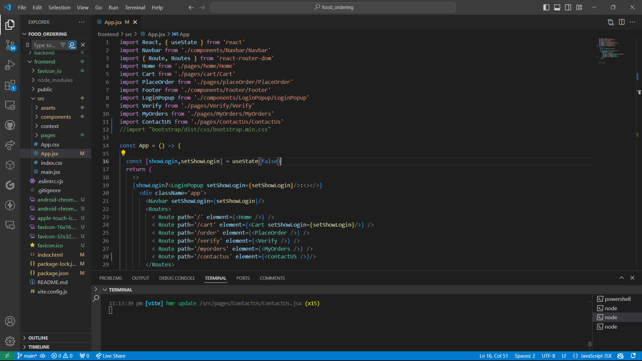

**Fig. 3.1 Visual Studio UI**

**3.3 Integration Between Frontend and Backend:**

UI/UX of frontend and functionality of backend is integrated with the help of the Express.js and Rest API call of ‘POST’ and ‘GET’ method, from we send the requested to backend with API calls and fetch the functionalities to the frontend.

**3.4 Backend Development:**

Design and implement a robust backend infrastructure to support the app's functionality, focusing on real-time data processing and secure user authentication and other functionality of the application using Node.js.

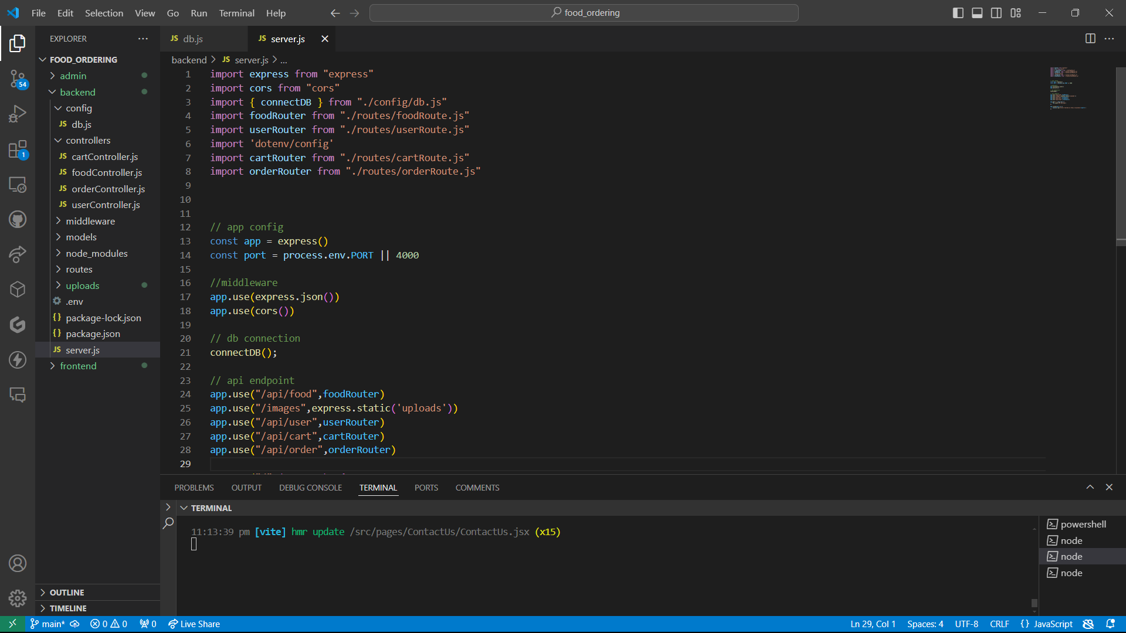

**Fig. 3.2 Code of the Backend**

**3.5 Database:**

Create a database using the MongoDB Atlas and connect to the application using the mongoose library of Node.js.

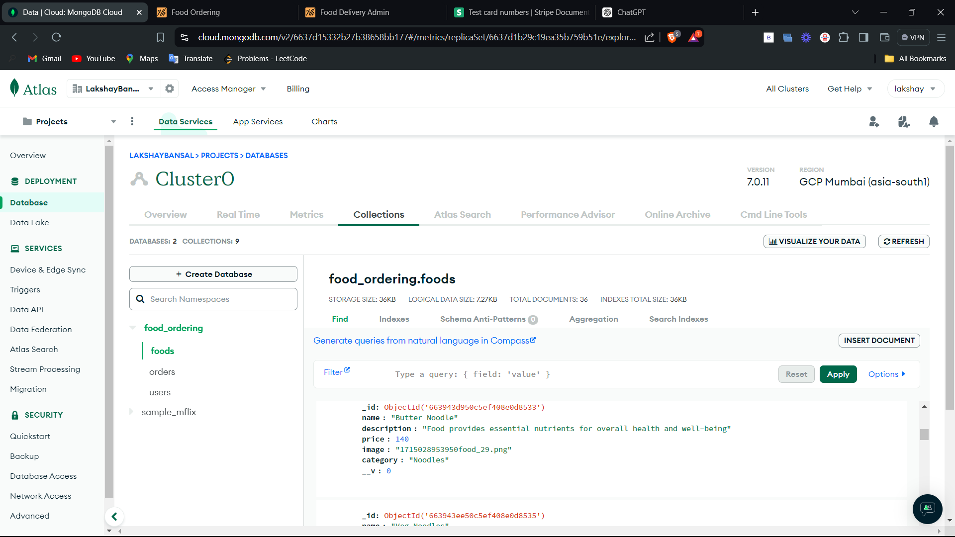

**Fig. 3.3 Representing the MongoDB Database**

**3.6 Frontend Development:**

* Implement the Website app's frontend using React.js development tools.
* Ensure responsiveness and smooth transitions between app screens, optimizing for various devices using media queries of CSS.
* Designing the Application UI with the help of CSS and structure and logics with the help of HTML and JavaScript functions respectively.
* Frontend Contains two modes one for the End User’s from where they can order food and another for the admin panel from where admin can manage all the orders and menu items.

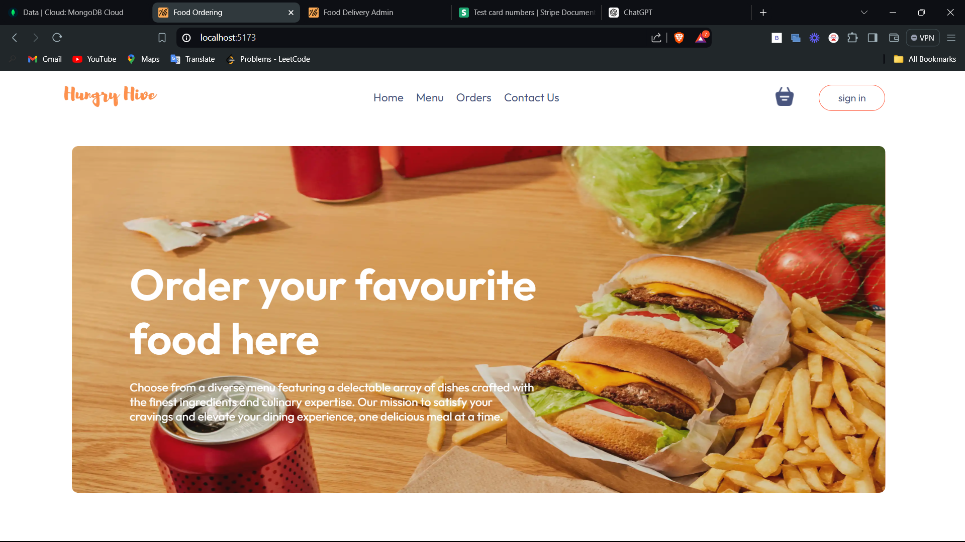

**Fig. 3.4 UI of the User’s Page**

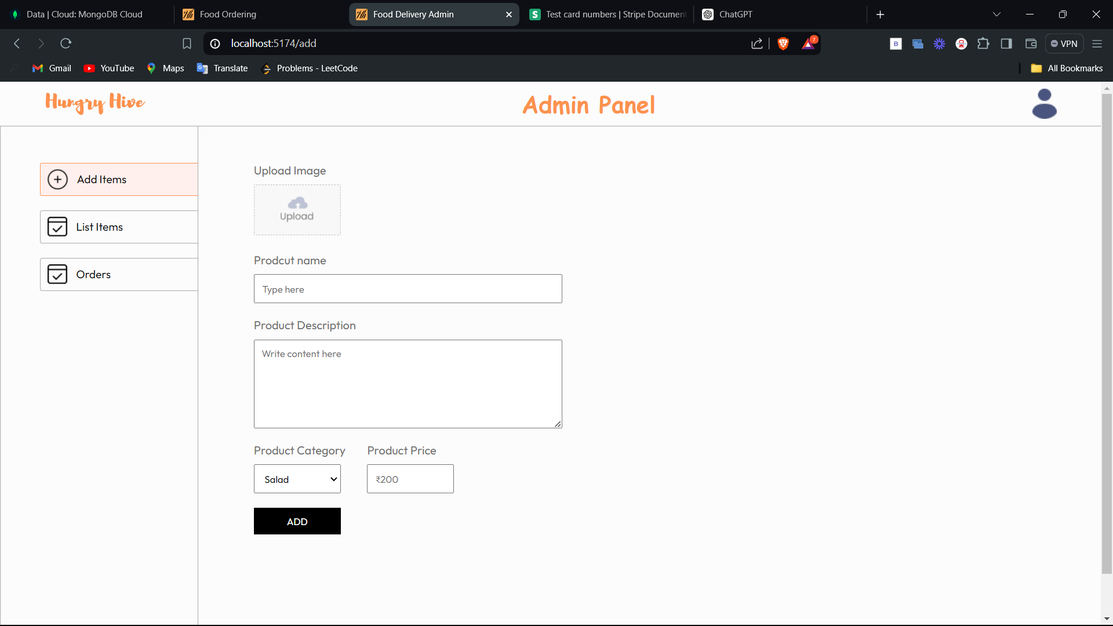

**Fig. 3.5 UI of the Admin Panel**

**Chapter 4**

**Result and Discussion**

**4.1 Functionalities in the Client Frontend:**

**4.1.1 Register User and Login:**

In this functionality customer can register to the application for first time and then after that he/she can access the application by login to site.

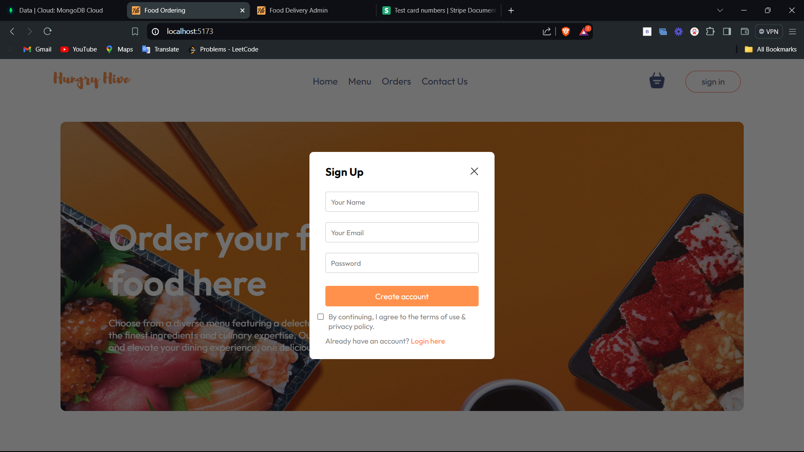

**Fig. 4.1.1 Register User Pop-Up**

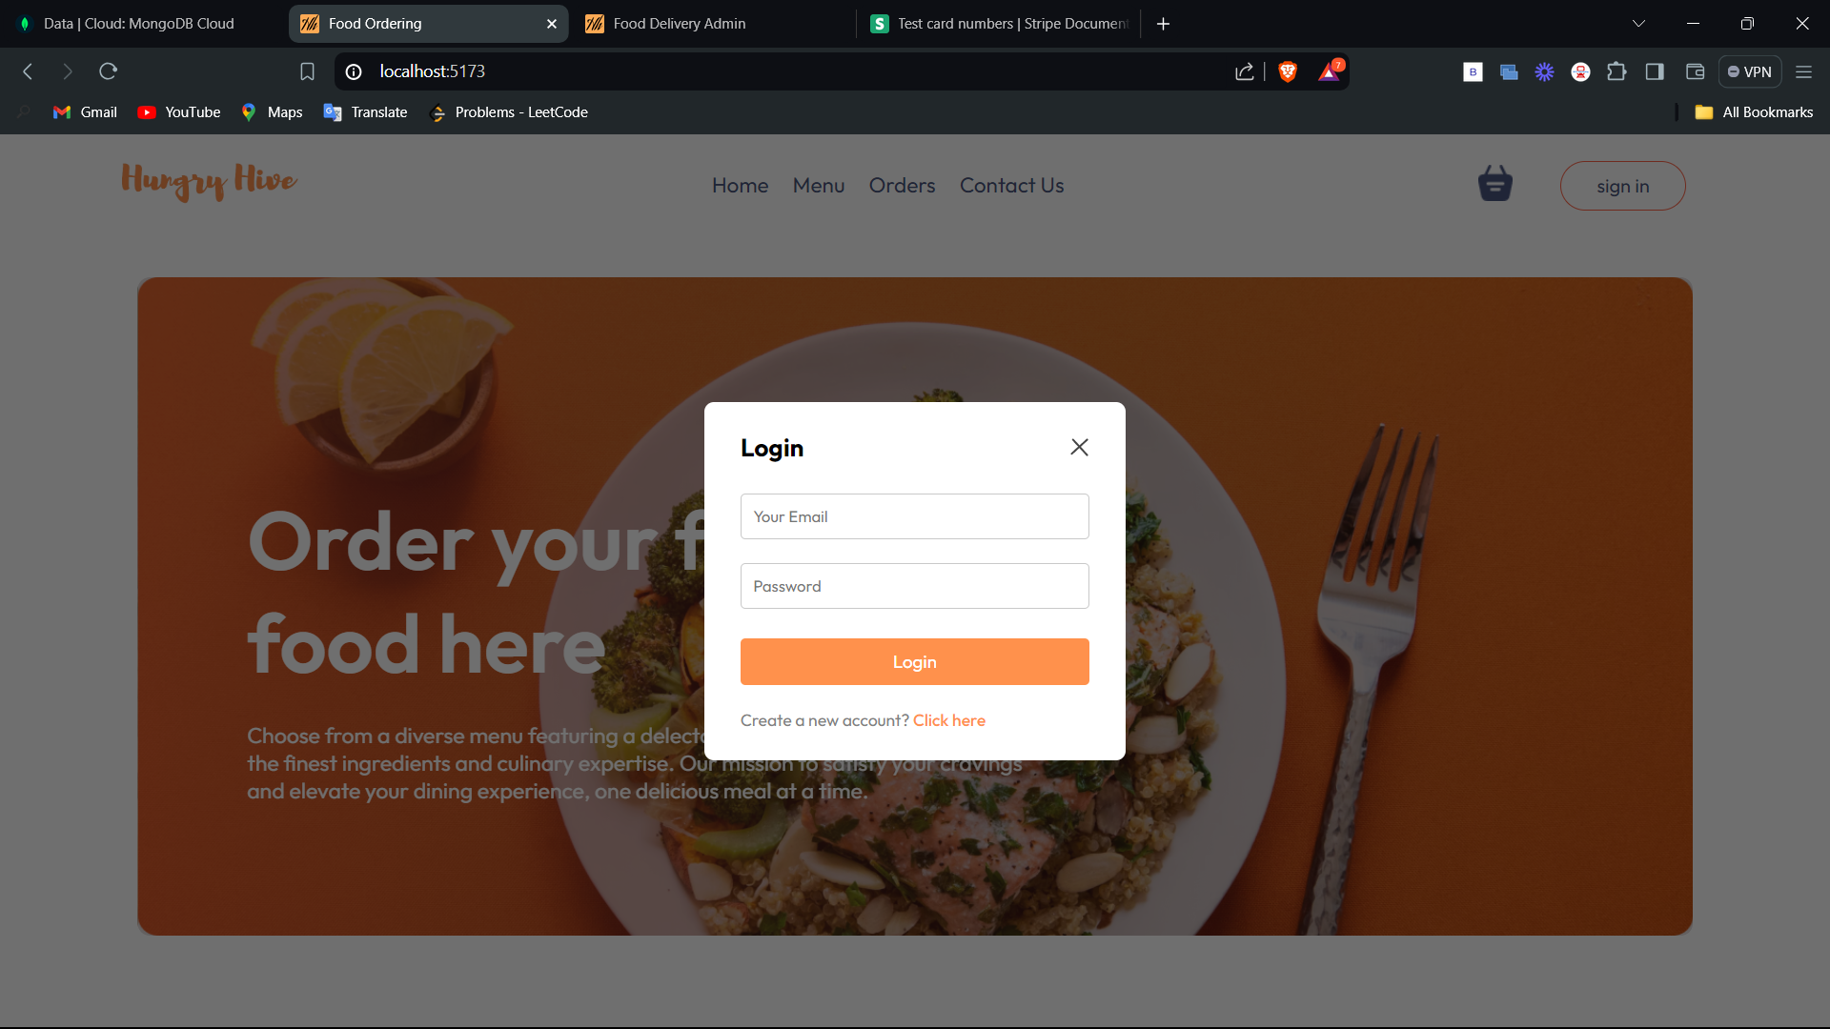

**Fig. 4.1.2 Login Pop-Up**

**4.1.2 Explore Menu:**

In this functionality user can check the menu by going to explore menu section in application and select the food of their choice.

In Addition, it also provides the filter option by clicking on the images of category.

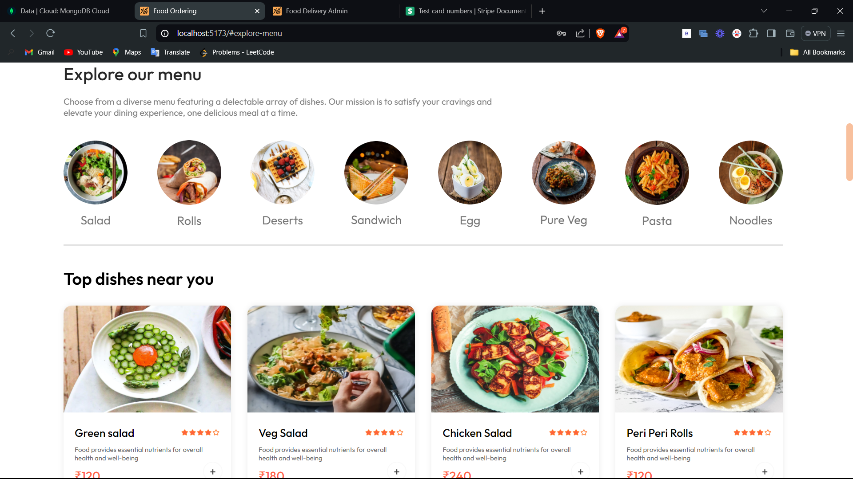

**Fig. 4.1.3 Explore Menu Page**

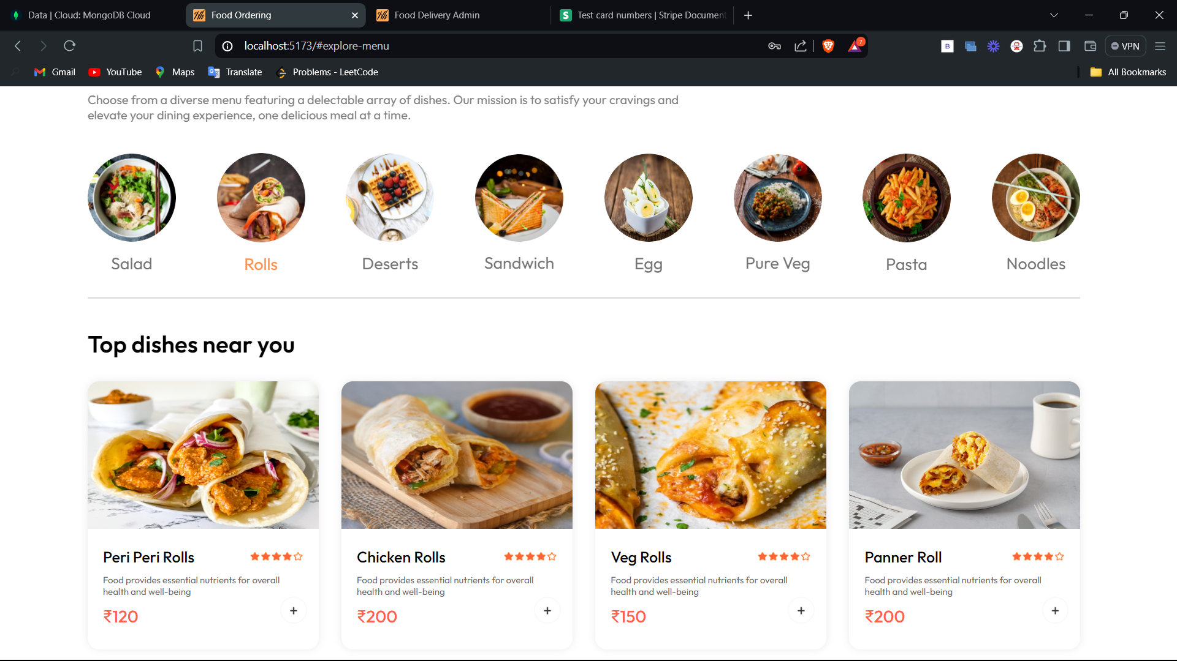

**Fig. 4.1.4 Menu with Filter Food by Category**

**4.1.3 Cart:**

In this user can check the food items that are selected by them to order and also, they can remove the items from the cart. It also shows the total amount of the order including delivery charges.

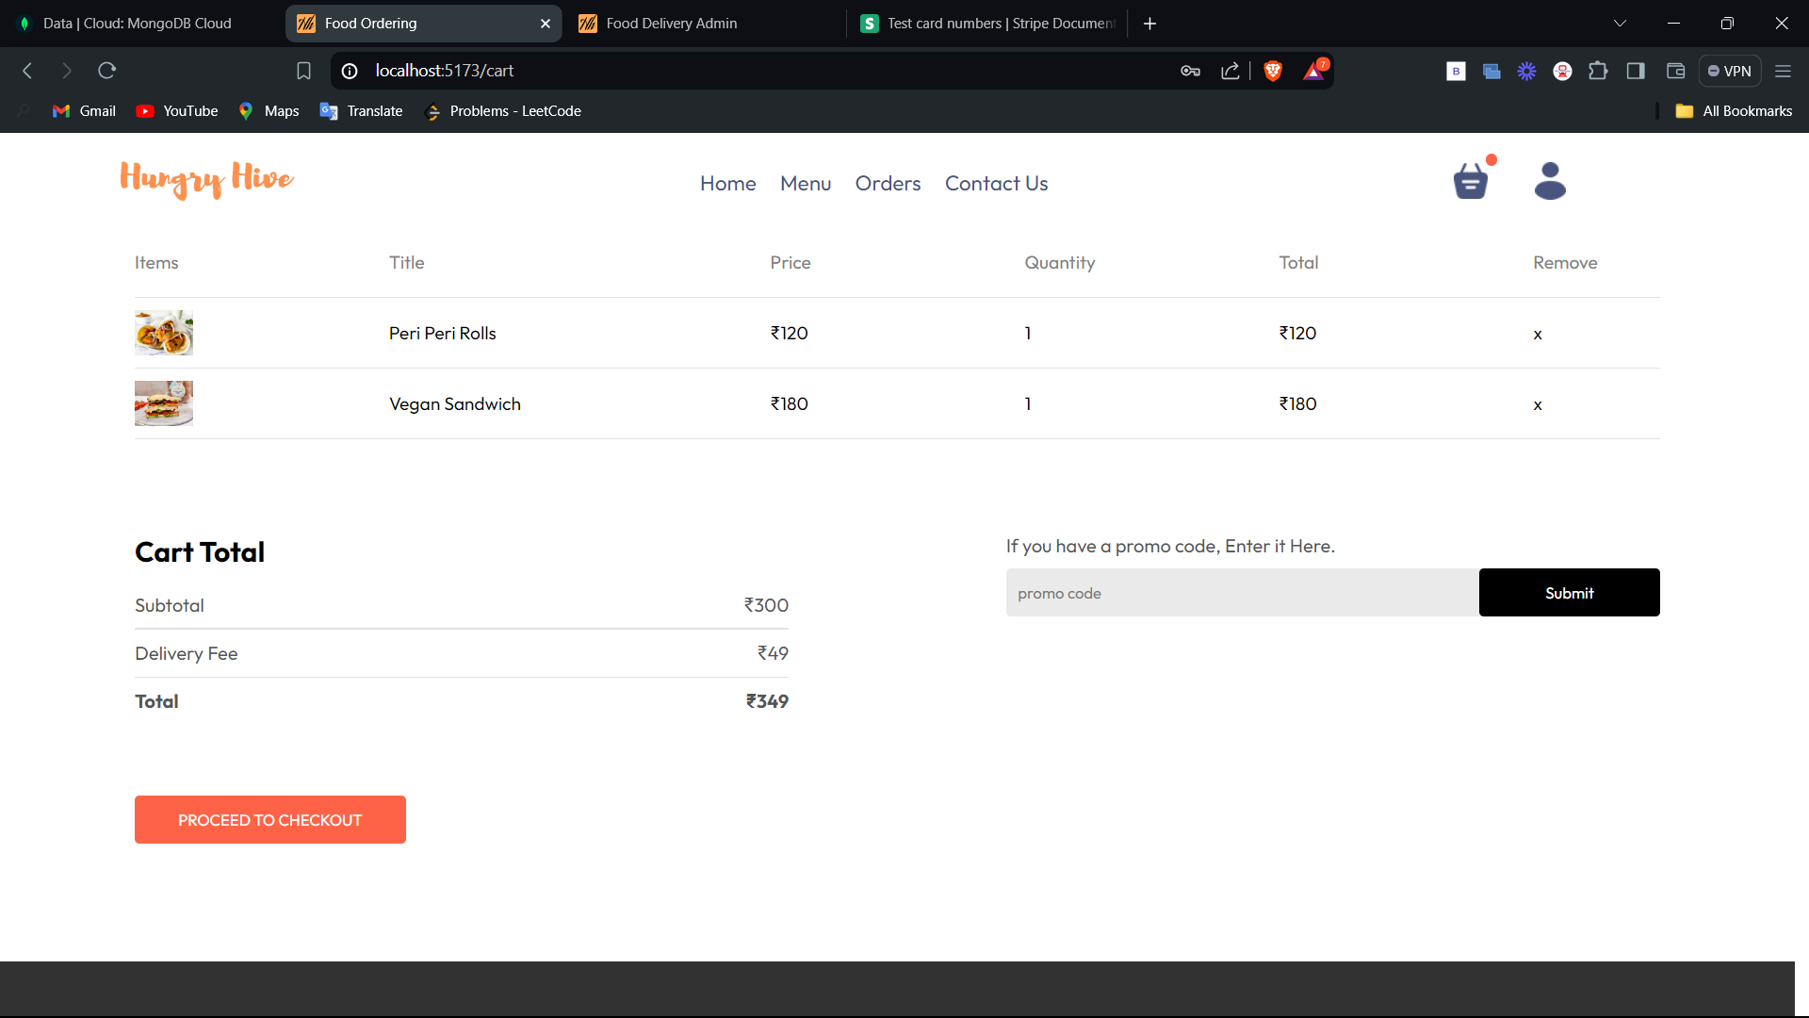

**Fig. 4.1.5 Cart Page**

**4.1.4 Proceed to Payment Page:**

In this user must mention their details like address, contact details for the delivery and then finally go to payment gateway.

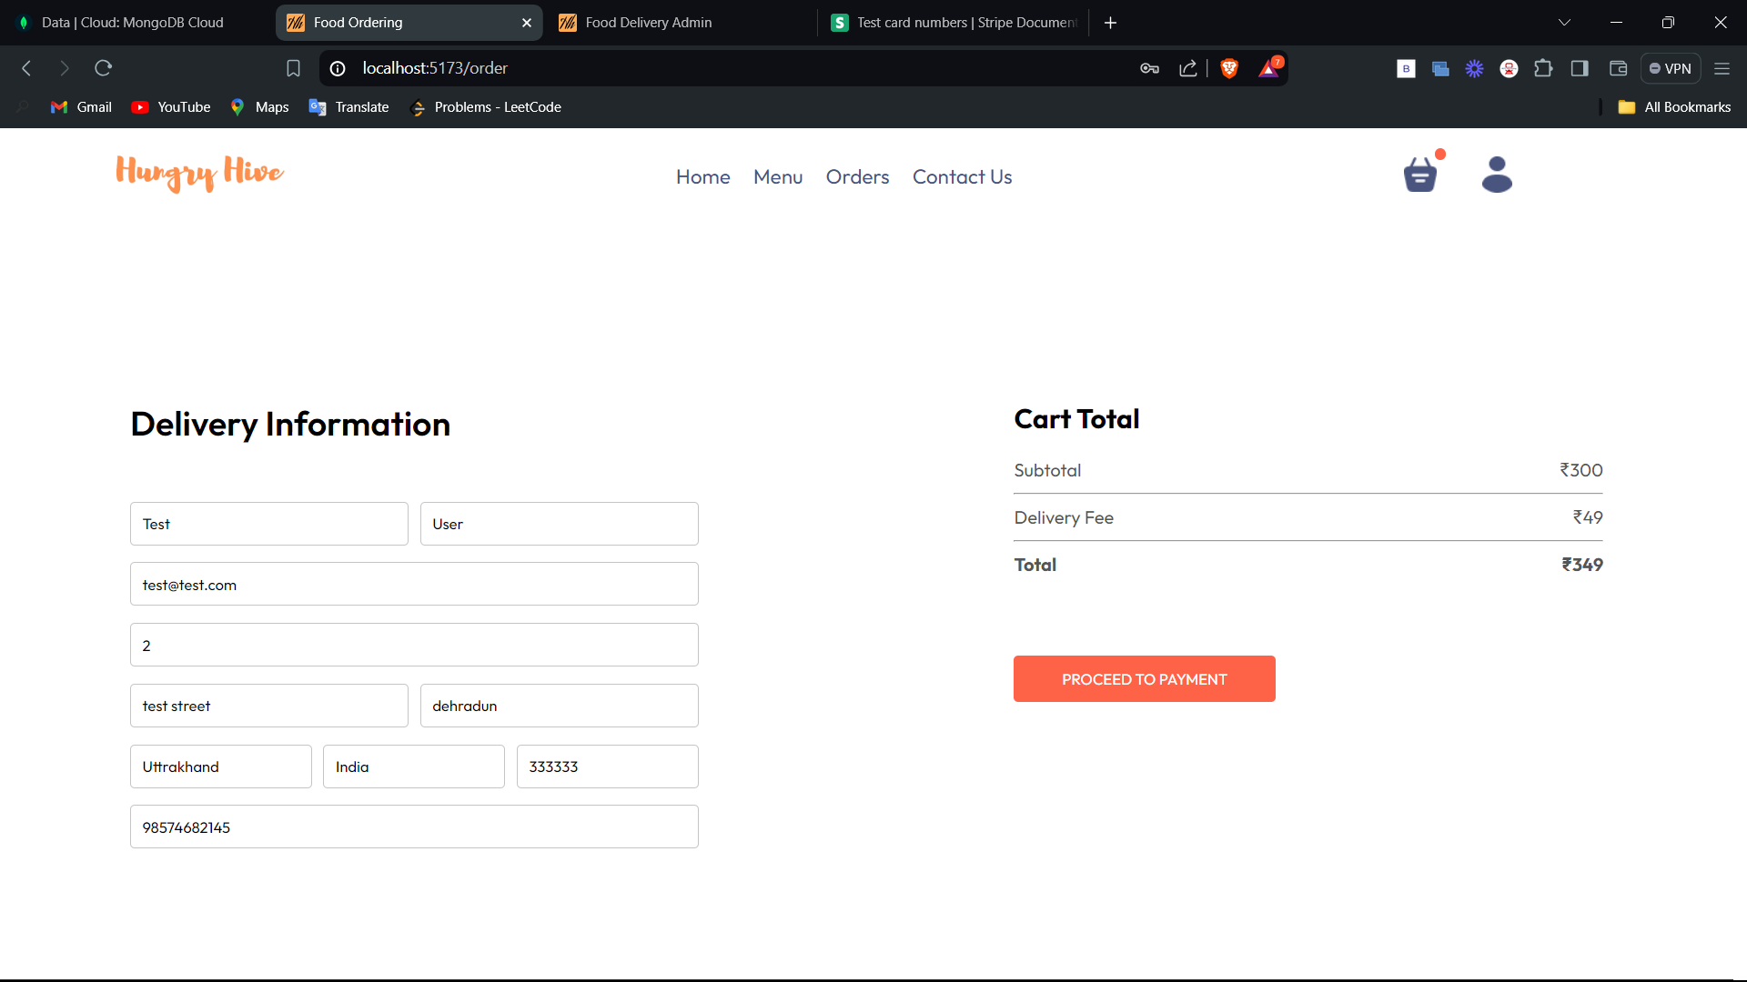

**Fig. 4.1.6 Proceed to Payment Page**

**4.1.4 Payment Gateway:**

Here user must mention the payment details, finalise the payment, if payment is successful then procced to orders page otherwise redirected to home.

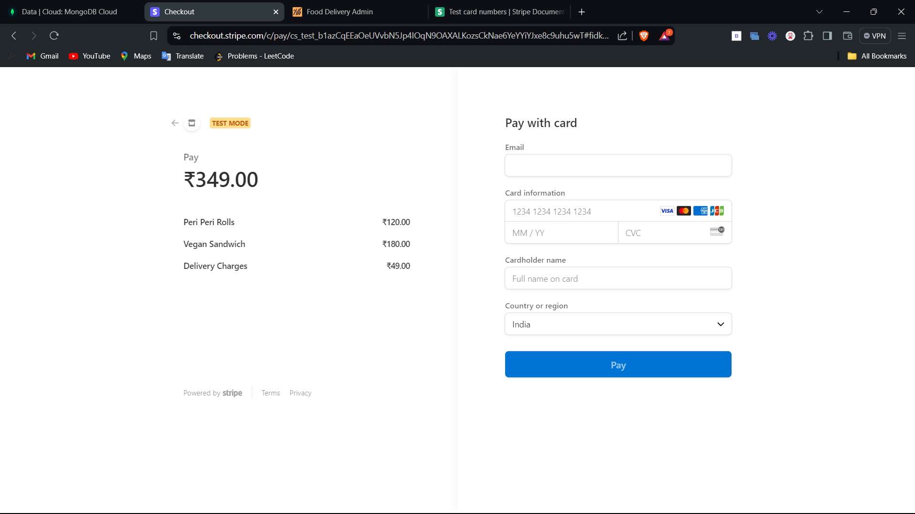

**Fig. 4.1.7 Stripe Payment Gateway**

**4.1.5 Orders Page:**

In this page user can his/her orders and track the status of the order.

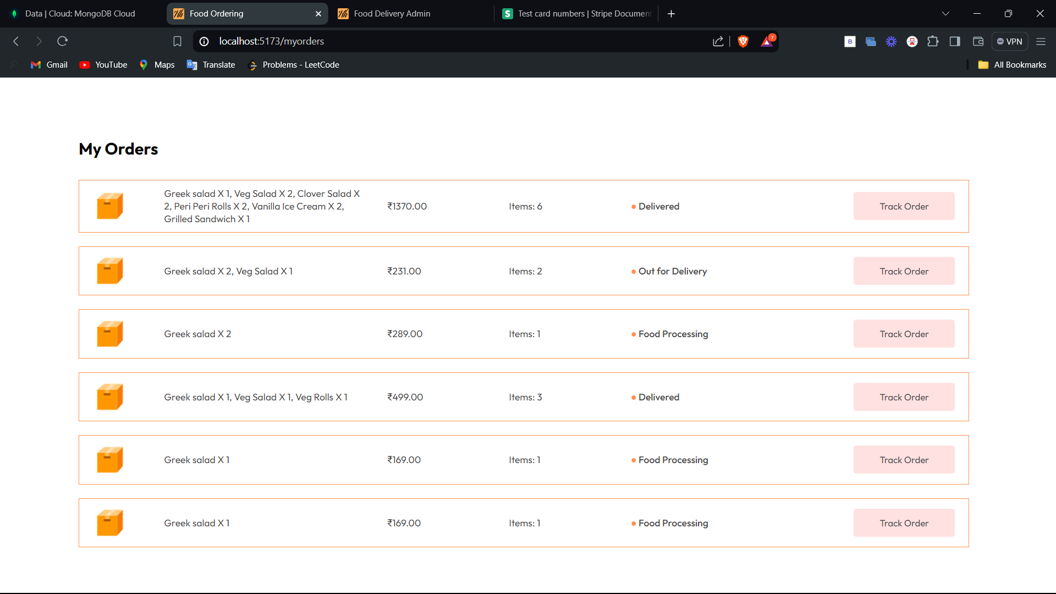

**Fig. 4.1.8 Orders Page**

**4.1.6 Contact Us:**

In this page user can write a query or message to give form or directly contact to the company person by given details.

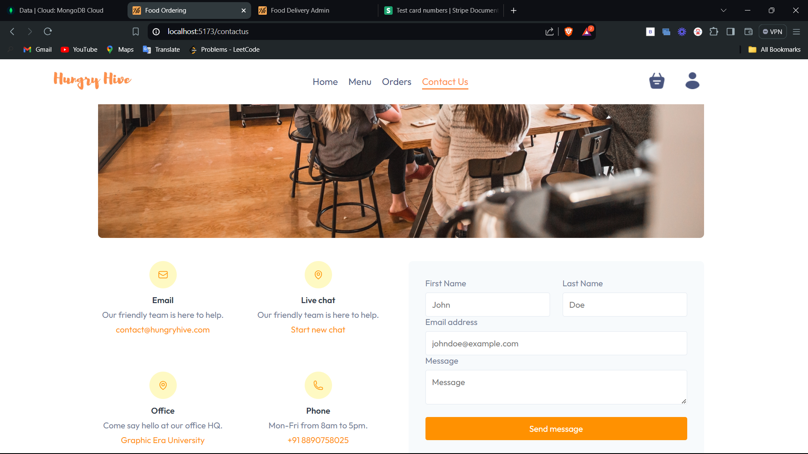

**Fig. 4.1.9 Contact Us Page**

**4.2 Functionality in the Admin Panel:**

**4.2.1 Add Items:**

In this admin can add new food items to the menu.

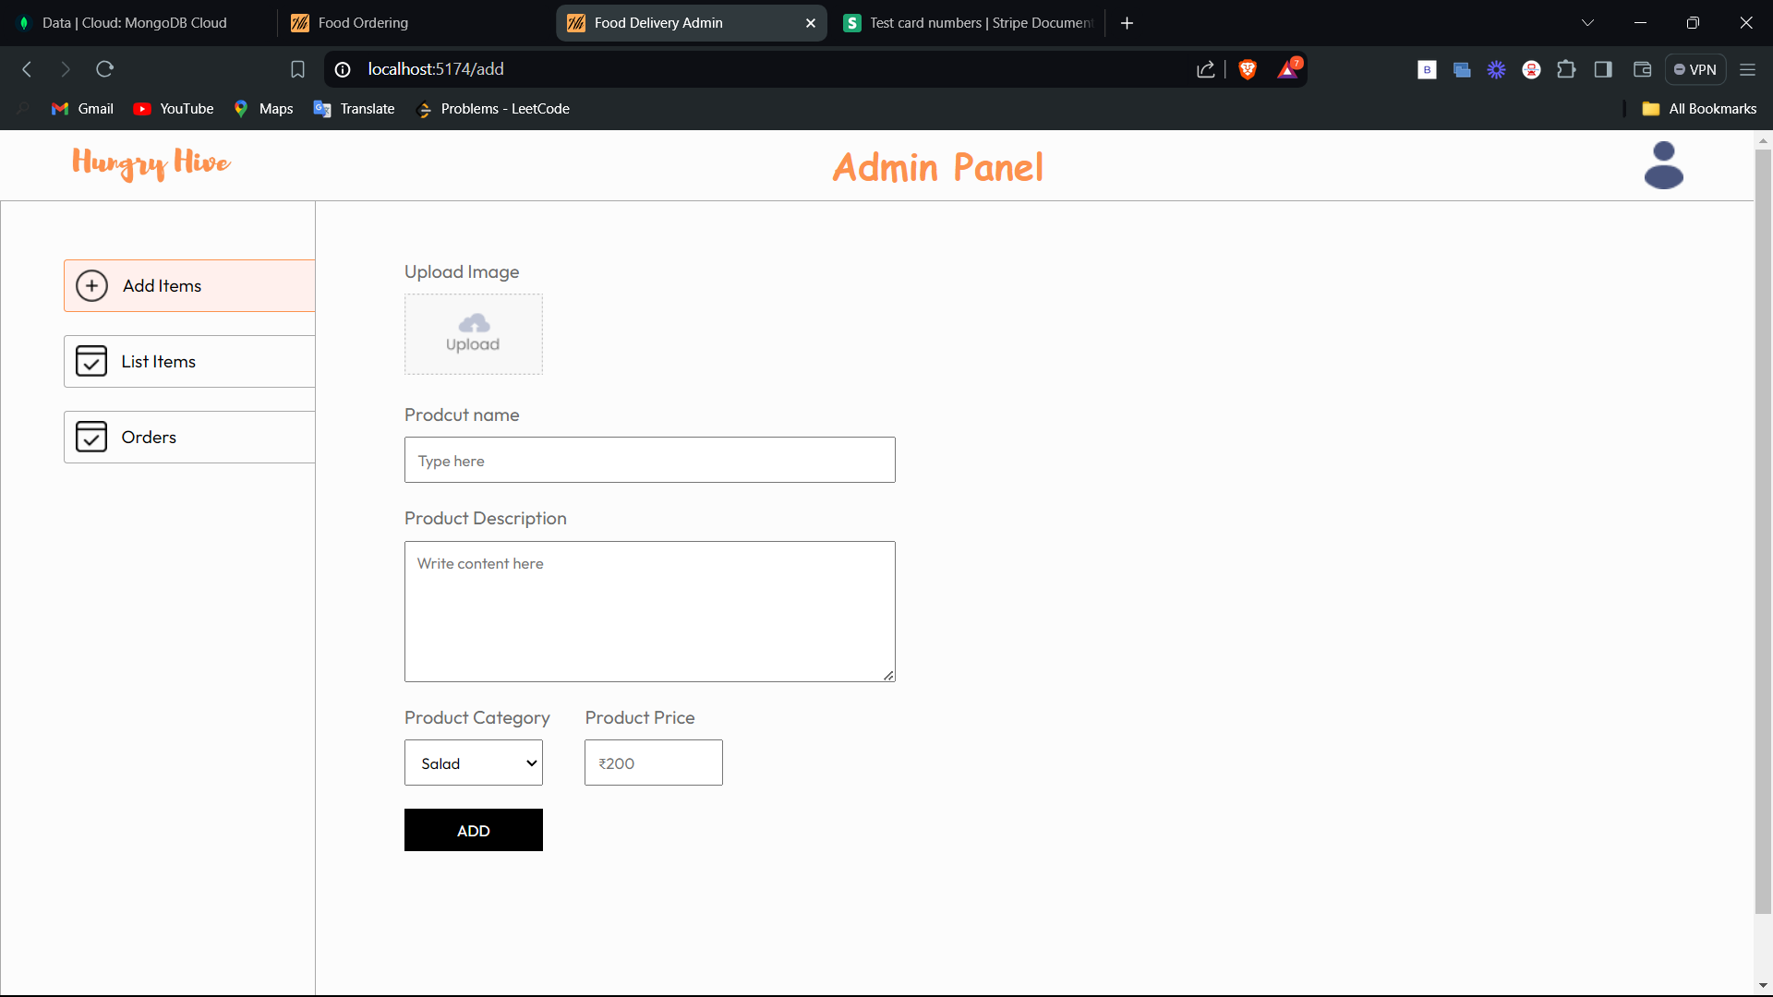

**Fig. 4.2.1 Add Items to database Page**

**4.2.2 List Items:**

It shows the list of all items currently present the menu of the user application and admin can remove the items from this list.

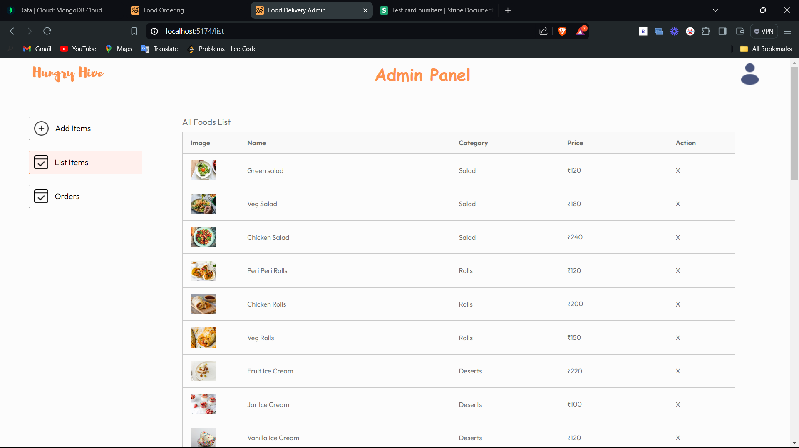

**Fig. 4.2.2 List Items Page**

**4.2.3 Orders Page:**

This page shows all order by all the users to the admin, so they can update the status of the order and prepare an order.

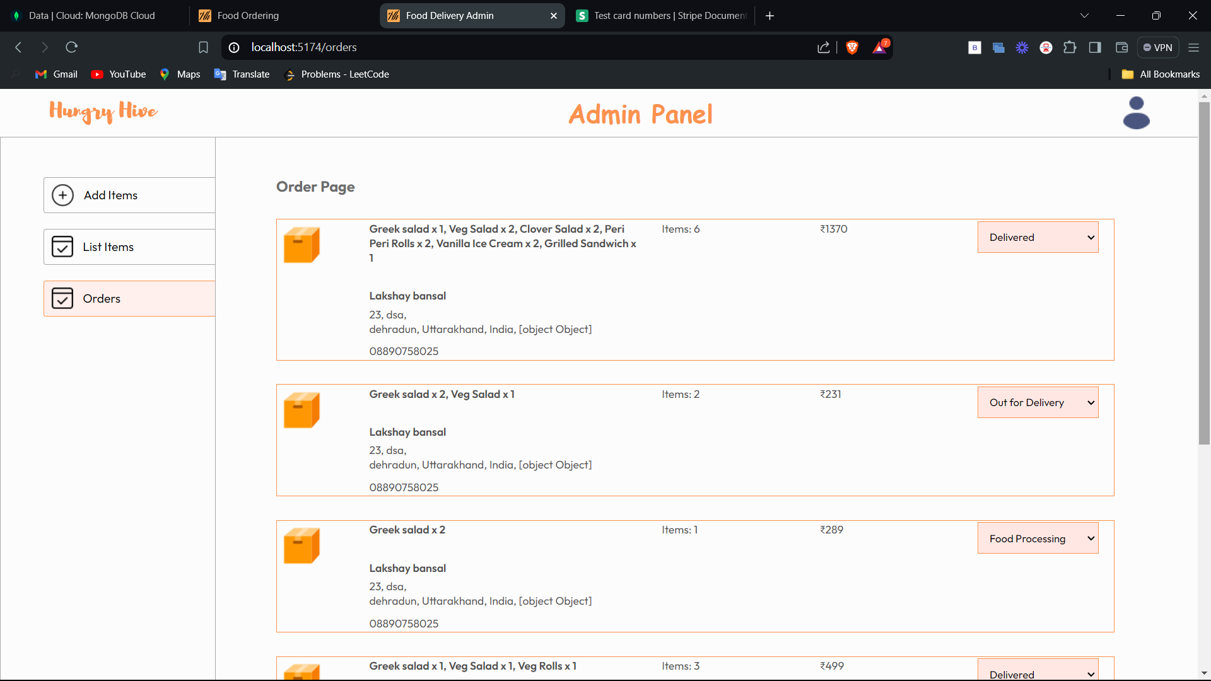

**Fig. 4.2.3 Order Page of Admin**

**Chapter 5**

**Conclusion and Future Work**

**5.1 Conclusion**

The online food ordering industry has witnessed significant growth due to the increasing reliance on digital solutions for everyday conveniences. The literature survey highlights the critical elements that contribute to the success of online food ordering apps, including user-friendly interfaces, extensive restaurant networks, real-time tracking, and personalized recommendations. Current solutions like Uber Eats, Grubhub, and Door Dash set high standards for user experience and operational efficiency.

Technological advancements such as mobile application development frameworks, cloud computing, and AI/ML integration play a pivotal role in enhancing app performance, scalability, and personalization. User behavior trends indicate a strong preference for convenience, variety, and promotions, with reviews and ratings being essential for building trust.

However, challenges such as ensuring order accuracy, managing delivery logistics, and maintaining data security persist. Overcoming these challenges requires continuous innovation and a deep understanding of user needs.

#### **5.2 Future Work**

Future work in the development of online food ordering apps should focus on several key areas:

**5.2.1** **Enhanced Personalization**:

* **AI-Driven Insights**: Utilize advanced AI algorithms to provide even more personalized recommendations based on user preferences, dietary restrictions, and past orders.
* **Behavioral Analysis**: Implement tools to analyze user behavior more deeply to anticipate needs and offer tailored suggestions.

**5.2.2 Improved Order Accuracy**:

* **Voice Recognition**: Integrate voice recognition technologies to enable voice-activated ordering, reducing the chances of order inaccuracies.
* **Augmented Reality (AR)**: Use AR to allow users to visualize their food orders, ensuring accuracy before placing the order.

**5.2.3 Advanced Delivery Solutions**:

* **Drone Deliveries**: Explore the feasibility of using drones for faster and more efficient deliveries, particularly in congested urban areas.
* **Autonomous Vehicles**: Invest in autonomous delivery vehicles to minimize human error and enhance delivery efficiency.

**5.2.4 Enhanced Security Measures**:

* **Blockchain Technology**: Implement blockchain for secure and transparent transactions, ensuring data integrity and security.
* **Advanced Encryption**: Use state-of-the-art encryption methods to protect user data and payment information.

**5.2.5 Sustainability Initiatives**:

* **Eco-Friendly Packaging**: Encourage restaurants to use biodegradable and eco-friendly packaging materials.
* **Carbon Footprint Tracking**: Develop features that allow users to track the carbon footprint of their orders and make sustainable choices.

**5.2.6 Expanded Features**:

* **Social Integration**: Incorporate social media features that allow users to share their favorite dishes and restaurants with friends.
* **Loyalty Programs**: Develop comprehensive loyalty programs that reward repeat customers with discounts, exclusive offers, and other incentives.

**References**

1. Li, X., & Mao, Y. (2019). **Online Food Delivery: Exploring the Factors Affecting Consumer Adoption and Satisfaction**. Journal of Service Research, 22(1), 112-129. doi:10.1177/1094670518776463
2. Jumia, N., & Mbwana, J. (2020). **Technological Innovations in the Food Delivery Industry**. International Journal of Hospitality Management, 85, 102-115. Doi: 10.1016/j.ijhm.2020.102115
3. Kimes, S. E. (2011). **Customer Perceptions of Electronic Food Ordering**. Cornell Hospitality Report, 11(2), 6-14.
4. Statista. (2023). **Online Food Delivery Worldwide - Market Data & Statistics**. Retrieved from Statista website
5. IBISWorld. (2022). **Online Food Ordering & Delivery Platforms in the US - Market Research Report**. Retrieved from IBISWorld website
6. MarketWatch. (2023). **Global Online Food Delivery Services Market Report**. Retrieved from MarketWatch website
7. Rahman, M., & Hussain, M. (2021). **The Role of Artificial Intelligence in Enhancing User Experience in Online Food Ordering Apps**. International Journal of Computer Science and Network Security, 21(5), 45-53.
8. Zhou, Y., & Zhou, L. (2020). **Security and Privacy in Online Food Ordering Systems**. Journal of Information Security and Applications, 55, 102-120. Doi: 10.1016/j.jisa.2020.102120
9. Chen, H., & Xu, Y. (2021). **The Impact of User Reviews and Ratings on the Popularity of Food Delivery Services**. Journal of Consumer Research, 48(3), 589-606. doi:10.1093/jcr/ucaa040
10. Grubhub. (2023). **Grubhub Features and Benefits**. Retrieved from [Grubhub Official Website](https://www.grubhub.com/)
11. Door Dash. (2023). **Innovative Delivery Solutions**. Retrieved from Door Dash Blog
12. Uber Eats. (2023). **Uber Eats Platform and Technology**. Retrieved from [Uber Eats Official Website](https://www.ubereats.com/)